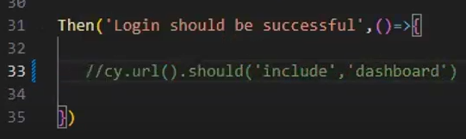

Git: it Is a distributed version control system for tracking changes in source code during software development.

GitHub: GitHub is a web-based version control and collaboration platform for software developers.

Github is a online S/W development platform used for storing, tracking and collaborating on software projects.

GitLab: It is a tool that provides DevOps software package that combites the ability to develop, secure and operate software in a single application.

Git Commands:

Git init(Git initialization): This command is used to create a local repository. Syntax: $git init Demo

Git add: This command is used to add one or more files to staging (index) area.

Syntax: $ git add * / Filename

Git status: This command is used to display the state of the working directory and the staging area.

Syntax: $ git status

Git commit: Commit command is used in two scenarios,

* commit -m: This command changes the head. It records or snapshots the file permanently in the version history with a message.

Syntax: $ git commit -m “Commit Message”

* commit -a: This command changes the commit any files added in the repository with git add and also commits any files you’ve changed since then,

Syntax: $git commit -a

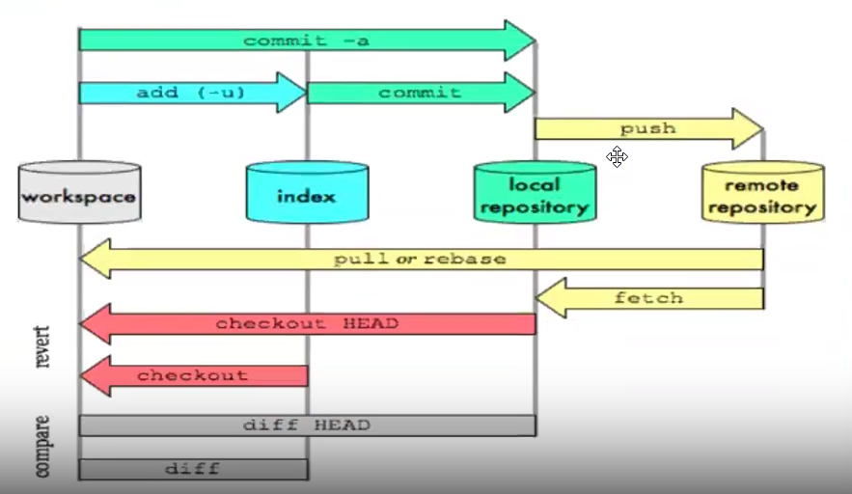

# Introduction to Git and GitHub

## Understanding version control:

Version control, also known as source control, is the practice of tracking and managing changes to software code . Version control systems are software tools that help software team manage

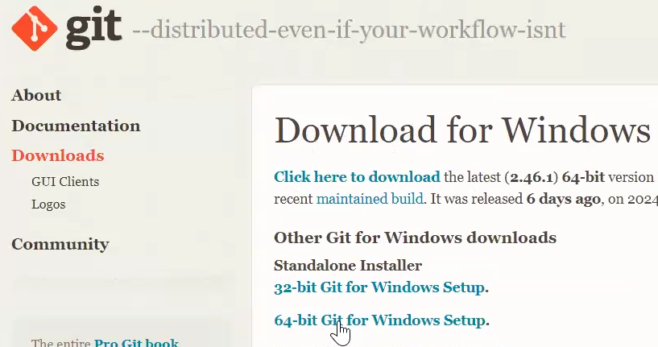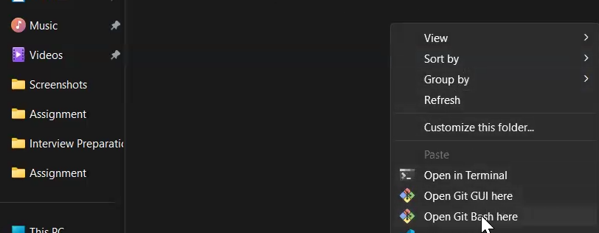

git commit -m “Adding Cypress Project”

git remote add origin <https://github.com/Mohit-test-coder/cypress-project.git>

git push origin master

